**JAIME’S ABCDE NEWSLETTER – 4/14/20**

1. Today we discussed that we have sent a request by letter to Senator Brian Kavanaugh, in reference to S. 8140-A to ask for a conference call to discuss his proposed bill on behalf of the members of NYCRAA and UnderOneRoofNY coalition. A copy of the letter is here for your reference. I encourage everyone to circulate this letter in its entirety to local officials and industry groups. Keeping the letter intact, will ensure that the messaging is consistent across the state. We plan on introducing amendments on this bill and are actively working on language.



1. We need the statistics and videos prepared on the impact of April Rent shortfalls and dealing with the emotional and physical nature of dealing with tenants during the COVID-19 crisis. Talk about financial impacts, extra costs of cleaning and hiring third parties, what the inability to evict is doing to potential units that could be re-rented, etc. please send these videos

It’s as easy as recording the video on your smartphone or desktop/laptop webcam. **Videos should be no longer than 1-minute. Please submit asap.**

We will accept almost any video file format, but these are the three most popular:

* .MP4
* .MOV
* .WVM

Once you’ve recorded your video, please use the FREE version of [WeTransfer](https://wetransfer.com/) tosend your video to Under One Roof. Instructions below:

* **Step 1**: Go to WeTransfer.com
* **Step 2**: Add your video file
* **Step 3**: Email to: [Advocacy@underoneroofny.org](mailto:Advocacy@underoneroofny.org)
* **Step 4**: Your email
* **Step 5**: Your message…which could look something like this, *“Hi there, this is [insert first & last name]. I am a property owner in [City, State] and manage [X # of properties]. Here is my video explaining what will happen to my business, employees, and tenants if I do not receive rent or if a rent strike begins. Thank you!”*

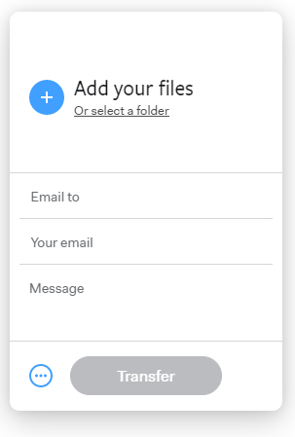

Last but not least, are the $25 donations to help fund the video campaign and help spread our message. You can donate $25 [online](https://events.r20.constantcontact.com/register/eventReg?oeidk=a07egqxnjyn0cae93dc&oseq=&c=&ch=), or you can mail a check to:

* NYCRAA

PO BOX 3956, Albany, NY 12203

**Make the check out to**: New York Capital Region Apartment Association

We appreciate all of you and your efforts in trying to help make this campaign as real and as authentic is possible!

To view, like and subscribe to our YouTube Channel please go here: <https://www.youtube.com/watch?v=e0TSoDnFNGs&t=12s>

1. Today we also reviewed Executive Order 202.16 which requires that for all essential business or entities, any employees who are present in the workplace ***shall be provided and shall wear face coverings when in direct contact with customers or members of the public.*** These face coverings must be provided by the employer, at its expense, and is subject to Public Health Law fines if not complied with.
   1. if an employee or contractor has their own mask it is fine as long as they comply with order.
   2. There is no affirmative responsibility to wash the masks for the employee.
   3. Compliance is mandatory when in direct contact with customers or members of the public.
   4. We would recommend strict compliance and mandate that everyone just has to wear a mask at all times. <https://www.governor.ny.gov/news/no-20216-continuing-temporary-suspension-and-modification-laws-relating-disaster-emergency>
2. Austin and I are speaking for BOMA on Thursday and it is open to non-members as well. “Implications of COVID-19: Responsibilities & Considerations for Landlords & Property Managers” this Thursday at 10 a.m. <https://zoom.us/webinar/register/WN_eq7LJYbdQ8mv2o48UZS7wg>
3. Eviction Referral Process- I am accepting referrals for eviction just to make sure we can start the data collection process and import the information into petition form to get it ready. I am not suggesting anyone start to serve the 5-day notice by certified mail or 14 day notice to quit. I still would like clarity before we waste time and money on that. We cover western and central NY and if there are people outside that area that need assistance please contact me.



Hope everyone is well and see you back here tomorrow at 2 p.m.

Jaime Michelle