JAIME’S ABCDE NEWSLETTER – 4/16/20

- Today we went over in detail the proposed S8190 Senator Salazar proposal. I have tried to extract the key points here. We are meeting with the Senate Chair of the Housing Committee on Monday on his S8140A bill and the assembly sponsor of the same bill.
- Austin and I spoke today on the Implications of a Tenant testing positive for COVID-19. We discussed the employer and housing provider points of view.

Here is the link to the recording: https://zoom.us/rec/play/6ZYociupjI3SNOU5QSDCqJwW9W6LKys1HMd86YFzEjhUHFXYVSnM7RGYODjh2eza9LCFSbqV7FkSnU_?continueMode=true&_x_zm_rtaid=bqNVCz54QmKmQHOFLdnL6w.1587051809271.8f06899e1fe21e60e1eaf2b0bbff6f37&_x_zm_rhtaid=264.

- The Governor issued a new order extending the Pause order until May 15, 2020. https://www.governor.ny.gov/news/amid-ongoing-covid-19-pandemic-governor-cuomo-issues-executive-order-requiring-all-people-new

- Last but not least send your videos! We asking for a $25 donation to help fund the video campaign and help spread our message. You can donate $25 online, or you can mail a check to: NYCRAA PO BOX 3956, Albany, NY 12203
Make the check out to: New York Capital Region Apartment Association
We appreciate all of you and your efforts in trying to help make this campaign as real and as authentic is possible!
To view, like and subscribe to our YouTube Channel please go here: https://www.youtube.com/watch?v=e0TSoDnFNGs&t=12s

- 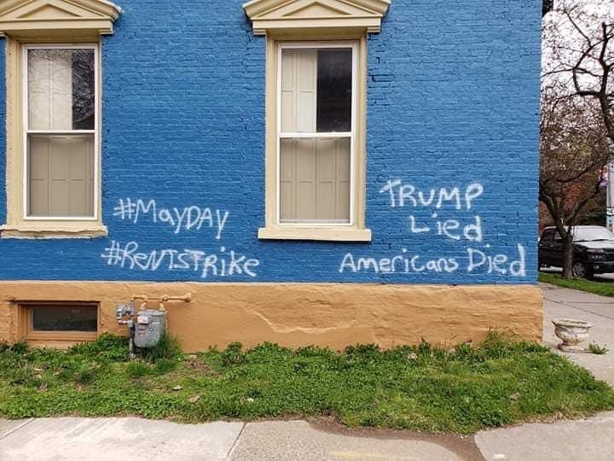
Please let us know if you see this type of graffiti and rent strike notices. We need to make this a conversation piece to correct this irresponsible and lawless behavior.

Eviction Referral Process- I am accepting referrals for eviction just to make sure we can start the data collection process and import the information into petition form to get it ready. I am not suggesting anyone start to serve the 5-day notice by certified mail or 14 day notice to quit. I still would like clarity before we waste time and money on that. We cover western and central NY and if there are people outside that area that need assistance please contact me.
Hope everyone is well and see you back here tomorrow at 2 p.m.
Jaime Michelle

