JAIME’S Always Be Consistent and Document Everything NEWSLETTER – 4/21/2020
- First, we (UOR) made the front page of the Times Union, above the fold! 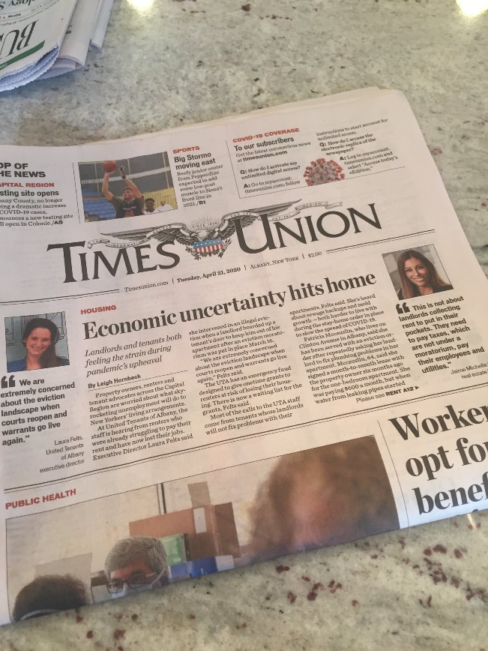
- Today, without mouse ears on, we spoke about the anticipated rent strike again. This will become constant conversation over the next week or so. Tenant advocate groups are pushing for solidarity of all those in buildings, regardless of whether or not there has been a financial impact due to COVID 19. Please keep all of us updated with information you are hearing on this.

- We (UOR) have a series of calls coming up that will discuss potential relief for landlords in light of being excluded from PPP loans, EIDL decreased funding, and looming rent strike. They include

  - Today, call with Assemblyman Steve Cymbrowitz, chair of the assembly housing committee and assembly sponsor of the S8190 bill.
  - Tomorrow, call with Senator Kavanaugh, sponsor of S8190, Chairman of the committee on housing.
  - Call with Assemblyman John McDonald on Friday, who has been vocal against the United Tenant’s organization and proposed rent strike.
  - NAA call on Thursday to advocate for NY on a federal level and to try and correct text of the CARES act, especially the eviction moratorium time frames.

- Thank you to FLLA for the survey you conducted. We are being asked the following questions and there is a need for data that compares last April to this April in terms of the rent shortfall. In addition, they want a number of people who belong to underoneroof. We have a master list but there may be members who are in a coalition partnership who haven’t been registered themselves as a member of underoneroof. If all coalition partners can send us a complete number of organizational members in your specific group, we can get a better number of the overall NYS representation. I recognize there may be some overlap.
  - For instance- FLLA has ________members
  - Freedom First REIA has ______________members

- If you own property in Buffalo, the RDC (the lending arm of the Erie County Industrial arm of the Erie County Industrial Agency) is currently offering disaster relief business loans to qualified Erie County businesses affected by the COVID-19 shutdown. https://www.ecidany.com/documents//RDC%20Disaster%20RFund%20Termsheet040820.pdf

- County Treasury Dep’t rep today and she indicated that they are extending the deferral until May. She said her supervisor just told her this today, so I’m hoping there will be additional guidance released by the County and/or press. According to the County Treasury Dep’t, the 3% interest of whatever is remaining owed on the tax bill will be extended until May. So, instead of the fourth installment being at 4.5% interest, it will be only a 3% interest rate. I will keep an eye out for releases from the County.

See you all tomorrow on FACEBOOK at 2!
Jaime Michelle

